1. Study of Generation & Reception of BPSK. kit
2 Study of Generation & Reception of BFSK kit
3 : Study of Generation & Detection of baseband signal using Matched Filter matlab code kit not available
Code :
clc; clear;

% Parameters
N = 10; % Number of bits
fs = 100; % Samples per bit
bits = randi([0 1], 1, N); % Random bits
nrz = 2*bits - 1; % NRZ: 0→-1, 1→+1

% Pulse shaping (rectangular pulse)
pulse = ones(1, fs);
tx = kron(nrz, pulse); % Transmitted signal

% Add noise
snr = 10; % SNR in dB
P = mean(tx.^2); % Signal power
noise = sqrt(P/10^(snr/10)) * randn(1, length(tx));
rx = tx + noise; % Received signal

% Matched filter (same as pulse shape)
mf = fliplr(pulse);
y = conv(rx, mf, 'same');

% Sample at bit centers
samples = y(fs/2:fs:end);
detected = samples > 0;

% Display results
disp('Transmitted bits:');
disp(bits);
disp('Detected bits:');
disp(detected);

% BER
ber = sum(bits ~= detected)/N;
disp(['BER: ', num2str(ber)]);
OUTPUT:
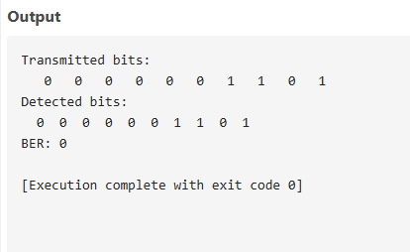
4. Study of Generation & Reception of DSSS. KIT
5 Simulation of Random Process. Matlab code
CODE:
A = 1; % Amplitude
f = 5; % Frequency in Hz
T = 1; % Total time duration in seconds
fs = 1000; % Sampling frequency
t = 0:1/fs:T; % Time vector

N = 10; % Number of random process realizations

% Initialize matrix to hold realizations
X = zeros(N, length(t));

% Generate realizations
figure;
hold on;
for i = 1:N
phi = 2*pi*rand(); % Random phase in [0, 2*pi]
X(i, :) = A * cos(2*pi*f*t + phi);
plot(t, X(i, :)); % Plot each realization
end

title('Random Process Realizations: A cos(2πft + φ)');
xlabel('Time (s)');
ylabel('Amplitude');
grid on;
hold off;% Parameters

OUTPUT:
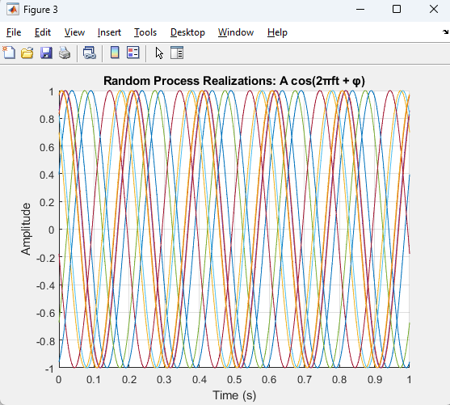
6. Simulation of performance of Binary PSK receiver in presence of noise MATLAB CODE
clc;
clear;

% Parameters
N = 1e6; % Number of bits
EbN0_dB = -4:1:10; % Eb/N0 range in dB
ber_sim = zeros(size(EbN0_dB)); % Preallocate for speed

% Generate random bits
bits = randi([0 1], 1, N);

% BPSK Modulation: 0 -> -1, 1 -> +1
symbols = 2*bits - 1;

for i = 1:length(EbN0_dB)
% Convert Eb/N0 from dB to linear
EbN0 = 10^(EbN0_dB(i)/10);

% Noise standard deviation (since Es = 1 for BPSK)
noise_std = sqrt(1 / (2 * EbN0));

% Generate AWGN
noise = noise_std * randn(1, N);

% Transmit over AWGN channel
received = symbols + noise;

% Receiver: Hard decision decoding
detected_bits = received > 0;

% Count bit errors
ber_sim(i) = sum(bits ~= detected_bits) / N;
end

% Theoretical BER for BPSK in AWGN
EbN0_lin = 10.^(EbN0_dB / 10);
ber_theory = 0.5 * erfc(sqrt(EbN0_lin)); % Replaces qfunc()
% Plotting
figure;
semilogy(EbN0_dB, ber_sim, 'bo-', 'LineWidth', 2);
hold on;
semilogy(EbN0_dB, ber_theory, 'r--', 'LineWidth', 2);
grid on;
xlabel('E_b/N_0 (dB)');
ylabel('Bit Error Rate (BER)');
title('BER Performance of BPSK over AWGN Channel');
legend('Simulated BER', 'Theoretical BER');
axis([-4 10 1e-6 1]);

OUTPUT:
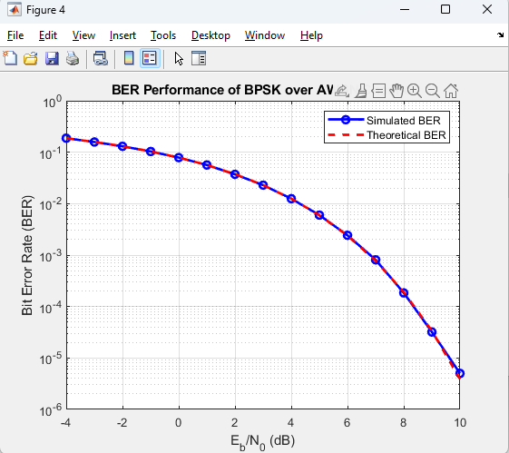
7. Simulation study of various Entropies and mutual information in a
communication system MATLAB CODE
clc;
clear;

% Define Channel Transition Matrix P(Y|X)
% Example: Simple 2x2 Channel
P_Y_given_X = [0.8 0.2; % P(Y=1|X=1), P(Y=2|X=1)
0.1 0.9]; % P(Y=1|X=2), P(Y=2|X=2)

% Define Input Distribution P(X)
P_X = [0.6, 0.4]; % Probability distribution for X = [X1, X2]

% Number of input and output symbols
[num_outputs, num_inputs] = size(P_Y_given_X);

% Compute Joint Distribution P(X, Y)
P_XY = zeros(num_outputs, num_inputs);
for x = 1:num_inputs
for y = 1:num_outputs
P_XY(y, x) = P_X(x) * P_Y_given_X(y, x); % Joint probability P(X,Y)
end
end

% Compute Marginal Distribution of Y
P_Y = sum(P_XY, 2); % P(Y)

% Compute Entropies
% H(X) - Entropy of input distribution
H_X = -sum(P_X .* log2(P_X + eps)); % Add eps to avoid log2(0)

% H(Y) - Entropy of output distribution
H_Y = -sum(P_Y .* log2(P_Y + eps)); % Add eps to avoid log2(0)

% H(Y|X) - Conditional entropy of Y given X
H_Y_given_X = 0;
for x = 1:num_inputs
for y = 1:num_outputs
p_y_given_x = P_Y_given_X(y, x);
if p_y_given_x > 0
H_Y_given_X = H_Y_given_X - P_X(x) * p_y_given_x * log2(p_y_given_x);
end
end
end

% Mutual Information I(X;Y)
I_XY = H_Y - H_Y_given_X;

% Display Results
fprintf('H(X) = %.4f bits\n', H_X);
fprintf('H(Y) = %.4f bits\n', H_Y);
fprintf('H(Y|X) = %.4f bits\n', H_Y_given_X);
fprintf('I(X;Y) = %.4f bits\n', I_XY);

OUTPUT:
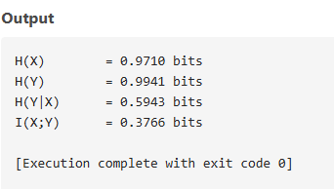
8 Shanonfeno and Hamming code simulation
clc;
clear;
close all;

% -----------------------------
% SHANNON–FANO CODING EXAMPLE
% -----------------------------

% Define symbols and their probabilities
symbols = {'A','B','C','D','E'};
probs = [0.30 0.25 0.20 0.15 0.10]; % must have SAME number of elements

% Check input length to avoid error
if numel(symbols) ~= numel(probs)
error('Error: symbols and probs must have the same length!');
end

% Normalize probabilities (in case they don't sum to 1)
probs = probs / sum(probs);

% Sort in descending order of probability
[probs, idx] = sort(probs, 'descend');
symbols = symbols(idx);

% Create initial table
tbl = table(symbols(:), probs(:), repmat({''}, numel(symbols), 1), ...
'VariableNames', {'Symbol','Prob','Code'});

% Recursively assign Shannon–Fano codes
tbl = assign_codes(tbl, 1, height(tbl));

% Display codes
disp('Symbol Probability Code');
for i = 1:height(tbl)
fprintf(' %s\t\t%.2f\t\t%s\n', tbl.Symbol{i}, tbl.Prob(i), tbl.Code{i});
end

% Example encoding
message = {'A','C','E','B','A','D'};
bitstream = '';
for i = 1:numel(message)
row = strcmp(tbl.Symbol, message{i});
bitstream = [bitstream tbl.Code{row}];
end
fprintf('\nOriginal Message: %s\n', strjoin(message, ' '));
fprintf('Encoded Bitstream: %s\n', bitstream);

% Decode back
decoded = {};
buffer = '';
for i = 1:length(bitstream)
buffer = [buffer bitstream(i)];
row = strcmp(tbl.Code, buffer);
if any(row)
decoded{end+1} = tbl.Symbol{row}; %#ok<SAGROW>
buffer = '';
end
end
fprintf('Decoded Message: %s\n', strjoin(decoded, ' '));

% -----------------------------------------
% Local recursive function for code assign
% -----------------------------------------
function tbl = assign_codes(tbl, i1, i2)
if i1 >= i2
return;
end
probs = tbl.Prob(i1:i2);
total = sum(probs);
cum = cumsum(probs);
[~, relIdx] = min(abs(cum - total/2));
split = i1 + relIdx - 1;

tbl.Code(i1:split) = cellfun(@(c)['0' c], tbl.Code(i1:split), 'UniformOutput', false);
tbl.Code(split+1:i2) = cellfun(@(c)['1' c], tbl.Code(split+1:i2), 'UniformOutput', false);

tbl = assign_codes(tbl, i1, split);
tbl = assign_codes(tbl, split+1, i2);
end

out put
Original Message: A C E B A D
Encoded Bitstream: 00011111000011
Decoded Message: A C E B A C

9. SourceCoding simulation
clc;
clear;
close all;

%% Source Symbols and Probabilities
symbols = {'A','B','C','D','E'}; % Example symbols
probs = [0.35, 0.25, 0.20, 0.15, 0.05]; % Probabilities of each symbol

% Check lengths
assert(numel(symbols) == numel(probs), 'symbols and probs must be same length');

%% Sort symbols by probability (descending)
[probs_sorted, idx] = sort(probs, 'descend');
symbols_sorted = symbols(idx);

%% Shannon-Fano Coding
codes = cell(size(symbols_sorted));

% Recursive function for Shannon-Fano coding
function codes = shannon_fano(symbols, probs, prefix)
if length(symbols) == 1
codes{1} = prefix;
return
end

total = sum(probs);
acc = 0;
split = 1;
% Find split point
for i = 1:length(probs)
acc = acc + probs(i);
if acc >= total/2
split = i;
break
end
end

% Recursively assign codes
codes_left = shannon_fano(symbols(1:split), probs(1:split), [prefix '0']);
codes_right = shannon_fano(symbols(split+1:end), probs(split+1:end), [prefix '1']);
codes = [codes_left, codes_right];
end

codes = shannon_fano(symbols_sorted, probs_sorted, '');

%% Display Codes
disp('Shannon-Fano Codes:');
for i = 1:length(symbols_sorted)
fprintf('%s : %s\n', symbols_sorted{i}, codes{i});
end

%% Encode a message
message = {'A','B','D','E','C','A','B'};
encoded_msg = '';
for i = 1:length(message)
index = find(strcmp(symbols_sorted, message{i}));
encoded_msg = [encoded_msg codes{index}];
end
disp(['Encoded message: ' encoded_msg]);

%% Decode the message
decoded_msg = {};
temp = '';
for i = 1:length(encoded_msg)
temp = [temp encoded_msg(i)];
for j = 1:length(codes)
if strcmp(temp, codes{j})
decoded_msg{end+1} = symbols_sorted{j};
temp = '';
break;
end
end
end
disp('Decoded message:');
disp(decoded_msg);

out put
Shannon-Fano Codes:
A : 00
B : 01
C : 10
D : 110
E : 111
Encoded message: 0001110111100001
Decoded message:
{'A'} {'B'} {'D'} {'E'} {'C'} {'A'} {'B'}

>>

10. simulation BPSK receiver

clc;
clear;
close all;

%% Parameters
N = 10000; % Number of bits
EbN0_dB = 0:2:12; % Eb/N0 range in dB

%% Transmitter
data = randi([0 1], 1, N); % Random binary data
bpskSymbols = 2*data - 1; % BPSK mapping: 0 -> -1, 1 -> +1

%% Preallocate BER
BER = zeros(1, length(EbN0_dB));

%% Receiver Simulation over AWGN
for i = 1:length(EbN0_dB)
% Calculate noise variance
EbN0 = 10^(EbN0_dB(i)/10);
noiseVar = 1/(2*EbN0); % BPSK: signal power=1

% AWGN Channel
noise = sqrt(noiseVar) * randn(1, N);
received = bpskSymbols + noise;

% Receiver: BPSK Demodulation
receivedBits = received > 0;

% BER Calculation
BER(i) = sum(data ~= receivedBits)/N;
end

%% Plot results
figure;
semilogy(EbN0_dB, BER, 'b-o', 'LineWidth', 2);
grid on;
xlabel('Eb/N0 (dB)');
ylabel('Bit Error Rate (BER)');
title('BPSK Receiver Simulation over AWGN');

out put
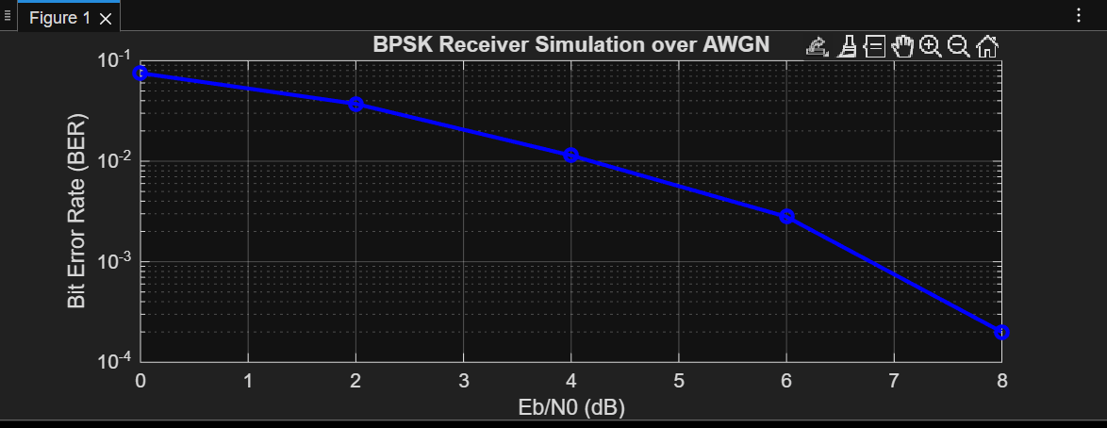

11. simulation M-ary PSK
clc;
clear;
close all;

%% Parameters
M = 8; % M-ary PSK
k = log2(M); % Bits per symbol
N = 1e5; % Number of bits
SNR_dB = 0:2:20; % SNR range in dB

%% Generate random data
data = randi([0 1], N, 1);

% Pad data so length is multiple of k
padLen = k - mod(length(data), k);
if padLen ~= k
data = [data; zeros(padLen,1)]; % Padding with zeros
end

%% Map bits to symbols (manual bi2de)
dataMatrix = reshape(data, k, []).'; % Each row = one symbol
dataSymbols = zeros(size(dataMatrix,1),1);

for idx = 1:size(dataMatrix,1)
bits = dataMatrix(idx,:);
val = 0;
for b = 1:k
val = val + bits(b)*2^(k-b); % left-msb convention
end
dataSymbols(idx) = val;
end

%% M-PSK Modulation
txSig = exp(1j*2*pi*dataSymbols/M); % Manual PSK modulation

%% Initialize BER array
BER = zeros(length(SNR_dB), 1);

%% AWGN Channel simulation
for i = 1:length(SNR_dB)
% Calculate noise power
SNR_lin = 10^(SNR_dB(i)/10);
noiseVar = 1/(2*SNR_lin); % Since unit power signal

% Add complex AWGN
noise = sqrt(noiseVar)*(randn(size(txSig)) + 1j*randn(size(txSig)));
rxSig = txSig + noise;

% M-PSK Demodulation
rxAngles = angle(rxSig);
rxAngles(rxAngles < 0) = rxAngles(rxAngles < 0) + 2*pi; % 0 to 2pi
rxSymbols = round(M*rxAngles/(2*pi));
rxSymbols(rxSymbols == M) = 0;

% Convert symbols back to bits (manual de2bi)
rxBits = zeros(length(rxSymbols), k);
for idx = 1:length(rxSymbols)
val = rxSymbols(idx);
for b = k:-1:1
rxBits(idx,b) = mod(val,2);
val = floor(val/2);
end
end
rxBits = rxBits.';
rxBits = rxBits(:); % Column vector

% Remove padded bits before BER calculation
rxBits = rxBits(1:N);

% Compute BER
BER(i) = sum(data(1:N) ~= rxBits) / N;
end

%% Plot BER vs SNR
figure;
semilogy(SNR_dB, BER, 'b-o', 'LineWidth', 2);
grid on;
xlabel('SNR (dB)');
ylabel('Bit Error Rate (BER)');
title([num2str(M), '-ary PSK over AWGN Channel']);

out put
